Revision Exercise: Section B
The exam won’t necessarily contain these questions exactly, but you can hopefully use them to get an idea of the types of things you’ll be asked. You can also see an approximate idea of how marks are generally allocated.

Exercise 1
Twelve participants were asked to solve a series of particularly difficult mathematical problems whose answers are all based on the same set of rules that are very difficult to explain. During the training session, participants were asked to solve 80 problems. In the test session, they had to solve a second set of 80 problems. For each session, the percentage of correct answers to the question asked was measured. The data are presented in the table below:

Table 1.
Percentage of correct answers

Participant | Training | Test
1 | 31 | 37
2 | 16 | 24
3 | 26 | 31
4 | 24 | 29
5 | 23 | 29
6 | 22 | 25
7 | 22 | 26
8 | 20 | 22
9 | 14 | 20
10 | 25 | 29
11 | 9 | 15
12 | 13 | 17

Data Familiarisation

Descriptives
 |  | N |  | Mean |  | SD |  | SE
Training |  | 12 |  | 20.42 |  | 6.29 |  | 1.81
Test |  | 12 |  | 25.33 |  | 6.23 |  | 1.79

Shapiro-Wilk
 |  |  |  |  |  | W |  | p
Test |  | - |  | Training |  | 0.95 |  | .705

Test Results
Measure 1 |  |  |  | Measure 2 |  | Test result |  | df |  | p |  |  | Effect size
Test |  | - |  | Training |  | 10.50 |  | 11 |  | < .001 |  | 3.03

- What is the IV? And the DV?
(3 marks)

- What is the design of the study?
(2 marks)

- What inferential test the researcher should use?
(2 marks)

- What is the alternative hypothesis?
(3 marks)

- The results of the test are presented below, summarize the findings and give a conclusion.
(8 marks)

- The researcher decided to run a two-tail test, explain why it is appropriate.
(2 marks)
Exercise 2

It is a very well-known phenomenon that if someone looks at an object, people will automatically look at the same object – this is referred to as ‘gaze cueing’. A group of researchers decided to look at this phenomenon using a classical Posner Cueing Task paradigm. They presented a central face to participants. The face looked to the same side (congruent), to the opposite side (incongruent) as a target or to a neutral (middle) position. They recorded whether participants saw the target (yes/no answer). The results are presented below. Assumptions of the test were met.
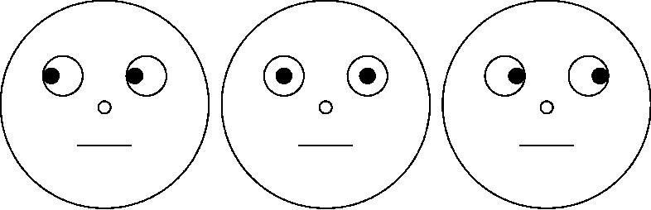

Table 2.
Frequency table of the participants’ answers and the type of cues
 |  | Type of cue
 |  | Neutral | Incongruent | Congruent
Participant’s answer | Yes | 41 | 16 | 63
 | No | 22 | 27 | 51

Results
 |  |  |  | Cue
Answer |  |  |  | Neutral |  | Incongruent |  | Congruent |  |  | Total
Yes |  | Count |  | 41 |  | 16 |  | 63 |  |  | 120
 |  | Expected count |  | 34.36 |  | 23.45 |  | 62.18 |  |  | 120
No |  | Count |  | 22 |  | 27 |  | 51 |  |  | 100
 |  | Expected count |  | 28.64 |  | 19.54 |  | 51.82 |  |  | 100
Total |  | Count |  | 63 |  | 43 |  | 114 |  |  | 220
 |  | Expected count |  | 63 |  | 43 |  | 114 |  |  | 220

 |  | Value |  | df |  | p
Test Result |  | 8.06 |  | 2 |  | .018
N |  | 220

- What type of data is this?
(2 marks)

- What kind of analysis would one use to analyse this data?
(3 marks)

- The results of the test are presented below. How would the results be written up?
(8 marks)

- What would the researcher conclude from this output?
(3 marks)

- Imagine that you were asked to redesign this study to have an experimental design. Which variable would you choose to change, and how would you change it?
(4 marks)

Exercise 3

The owner of a supermarket wants to investigate the average waiting time at checkouts and see if there is a relationship between the number of checkouts opened and waiting time. For 7 days, he recorded the number of checkouts opened and the average waiting time (in minutes). The supermarket owner predicts that where the number of checkouts opened increases, the average waiting time will decrease. The results of the analysis are reported below. Regarding the assumption checks: a Shapiro-Wilk test revealed

Table 3.
Average waiting time (in minutes) and number of checkouts open
Weekday | Number of checkouts open | Average waiting time (in minutes)
Monday | 3 | 16
Tuesday | 4 | 12
Wednesday | 5 | 9.6
Thursday | 6 | 7.9
Friday | 8 | 6
Saturday | 10 | 4.7
Sunday | 12 | 4

Shapiro-Wilk
 | W | p
Checkouts open | 0.951 | 0.705
Wait time | 0.499 | 0.420

Figure 1.

Number of checkouts open vs. Average waiting time (in minutes)
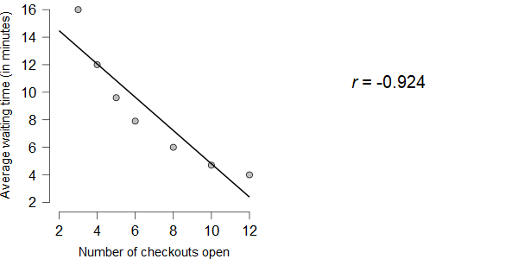
Results
 |  |  |  |  |  | Test |  | p
Number of checkouts open |  | - |  | Average waiting time (mins) |  | -0.924 |  | 0.041

- What test did the supermarket owner decided to conduct?
(2 marks)

- Why is it the most appropriate?
(2 marks)

- What was the supermarket owner’s hypothesis?
(2 marks)

- Write up and interpret the results.
(8 marks)

- Does the analysis support the supermarket owner’s prediction?
(2 marks)

- The supermarket owner thinks that whether the shop is busy or not might have an effect on the awaiting time. To examine this, he wants to analyse the possible correlation between waiting times and if the shop is busy or not busy. Are there any possible problems with the suggested analyses? If yes, explain the problem.
(4 marks)

